A Project Report On

Cipher Guard

Submitted in partial fulfillment of the requirement for the award of the degree

Bachelor of Science (Information Technology)
(B.Sc IT)

Academic Year 2026-27

Shubham Chavda (92400588043)
Pratham Shinde (92520588002)
Sahil Modi (92400588064)

Internal Guide
Prof. Tirth Bhadeshiya



Rajkot-Morbi Road, At&PO : Gauridad, Rajkot 360 003. Gujarat. India.


Bachelor of Science (Information Technology)
(B.Sc IT)

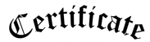

This is to certify that the project work entitled

Cipher Guard

submitted in partial fulfillment of the requirement for

the award of the degree of
Bachelor of Science (Information Technology)

of the

Marwadi University

is a result of the bonafide work carried out by

Shubham Chavda (92400588043)

Pratham Shinde (92520588002)

Sahil Modi (92400588064)

during the academic year 2026-27

Faculty Guide |  | HOD |  | Dean

DECLARATION

I/We hereby declare that this project work entitled Cipher Guard is a record done by me.

I also declare that the matter embodied in this project is genuine work done by me and has not been submitted whether to this University or to any other University / Institute for the fulfillment of the requirement of any course of study.

Place : marwadi university
Date : 08/09/2026

Shubham Chavda (92400588043) Signature :
Pratham Shinde (92520588002) Signature :
Sahil Modi (92400588064) Signature :

CONTENTS

Chapters | Particulars | Page No.
1 | Introduction to Project Definition
2  2.1 | PREAMBLE  Module description
3 | REVIEW OF LITERATURE  Analyze, Study and Compare the similar types of the systems/applications and highlights major findings
4  4.1  4.2 | TECHNICAL DESCRIPTION  Hardware Requirement  Software Requirement
5  5.1  5.2  5.3  5.4  5.5  5.6  5.7  5.8  5.9 | SYSTEM DESIGN AND DEVELOPMENT  (Only applicable diagrams)  - Algorithm  - Flow Chart  - Data Flow Diagram  - Class Diagram  - Use Case Diagram  - Sequential Diagram  - Activity Diagram  - Menu Design  - Code of the module
6 | SYSTEM TESTING
7 | CONCLUSION
8  8.1 | LEARNING DURING PROJECT WORK  Future Enhancement
9  9.1  9.2 | BIBLIOGRAPHY  Online References  Offline References

FIGURE INDEX

Sr. No. | Figure No. | Particulars | Page No.
1 | Figure 5.2 | Flowchart | 12
2 | Figure 5.3 | Data Flow Diagram | 13
3 | Figure 5.4 | Class Diagram | 14
4 | Figure 5.5 | Use Case Diagram | 15
5 | Figure 5.6 | Sequential Diagram | 16
6 | Figure 5.7 | Activity Diagram | 17
7 | screenshot | Menu Design | 18

- 1. Introduction:-

The Cipher Guard is a mini project designed to demonstrate the basic concepts of cryptography and secure communication. It converts a readable message (plaintext) into an unreadable form (ciphertext) using different encryption techniques.

This project implements three classical encryption methods: Caesar Cipher, Playfair Cipher, and Rail Fence Cipher. Each method uses a different technique to protect the message. The main objective of this project is to understand how encryption works and how different cryptographic methods can be used to secure information.

- 2. Preamble:-

The Cipher Guard is developed to provide a basic understanding of message security and cryptography. The project focuses on encrypting messages using three classical techniques: Caesar Cipher, Playfair Cipher, and Rail Fence Cipher.

The tool provides a simple way for users to enter a message, select an encryption method, and obtain the encrypted message. This project helps in understanding the basic principles of encryption and the importance of protecting information from unauthorized access.

- 2.1 Module description

The Cipher Guard consists of the following modules:
- User Input Module – Allows the user to enter the message and required key or settings.
- Caesar Cipher Module – Encrypts the message by shifting each character by a fixed number of positions.
- Playfair Cipher Module – Encrypts the message using a 5×5 matrix generated from a given keyword.
- Rail Fence Cipher Module – Encrypts the message by arranging characters in a zigzag pattern across multiple rails.
- Output Module – Displays the encrypted message to the user.

- 3. Review of literature :-

Cryptography is an important field of information security that focuses on protecting data from unauthorized access. Various encryption techniques have been developed to secure messages during communication.

Classical encryption methods such as the Caesar Cipher, Playfair Cipher, and Rail Fence Cipher are commonly used to understand the basic principles of cryptography. The Caesar Cipher uses character shifting, the Playfair Cipher encrypts pairs of letters using a matrix, and the Rail Fence Cipher rearranges characters using a zigzag pattern.

The study of these techniques provides a basic understanding of how plaintext can be converted into ciphertext and how encryption can be used to improve message security. These methods are mainly useful for educational purposes and for understanding the foundation of modern cryptographic techniques.

- 4. Technical description:-

4.1 Hardware requirement:-

- Processor: Intel Core i3 or equivalent
- RAM: 4 GB or above
- Storage: 500 MB free space
- Input Device: Keyboard and Mouse
- Output Device: Monitor/Display
- System: Desktop or Laptop

4.2 Software requirement:-

- Operating System: Windows 10/11 or equivalent
- Programming Language: Python
- IDE/Editor: Python IDLE / VS Code
- Python Version: Python 3.x
- Libraries: Standard Python libraries
- Browser: Google Chrome or any modern web browser (if required)

5. System design and development:-

5.1 Algorithm

Step 1: Start
Start the Cipher Guard.

Step 2: Enter Message
Allow the user to enter the message that needs to be encrypted or decrypted.

Step 3: Select Encryption Method
The user selects one of the following methods:
- Caesar Cipher
- Playfair Cipher
- Rail Fence Cipher

Step 4: Enter Key
Accept the required key from the user. Default keys are provided if the user does not enter one.

Step 5: Perform Encryption/Decryption
- Caesar Cipher: Shift each alphabet character forward for encryption and backward for decryption according to the key.
- Playfair Cipher: Create a 5×5 matrix using the key and encrypt/decrypt pairs of characters according to the Playfair rules.
- Rail Fence Cipher: Arrange characters in a zigzag pattern across the specified number of rails for encryption and reconstruct the zigzag pattern for decryption.

Step 6: Display Result
Display the encrypted or decrypted message along with the steps performed.

Step 7: Clear
The user can clear the message, result, and steps using the Clear button.

Step 8: Stop
End the process when the user closes the application.

5.2 Flowchart :-

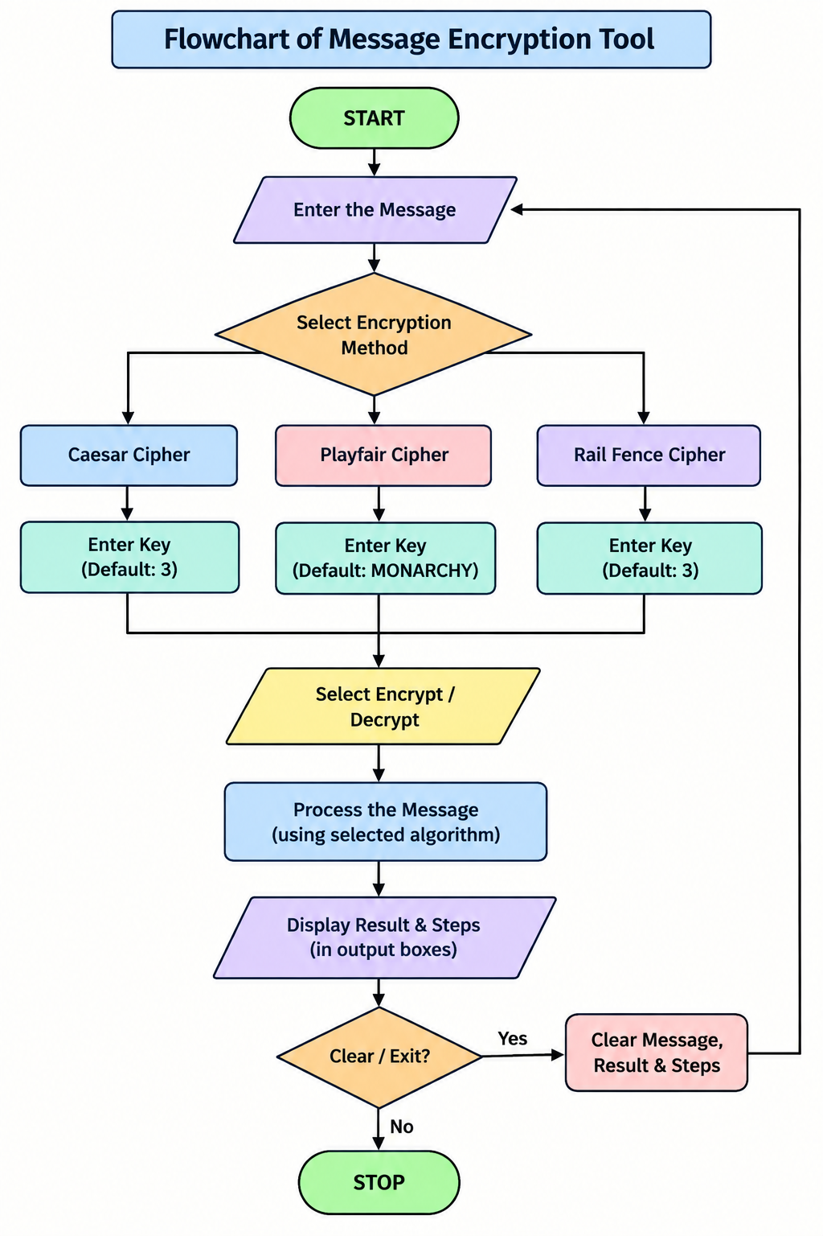

5.3 Data Flow Diagram :-

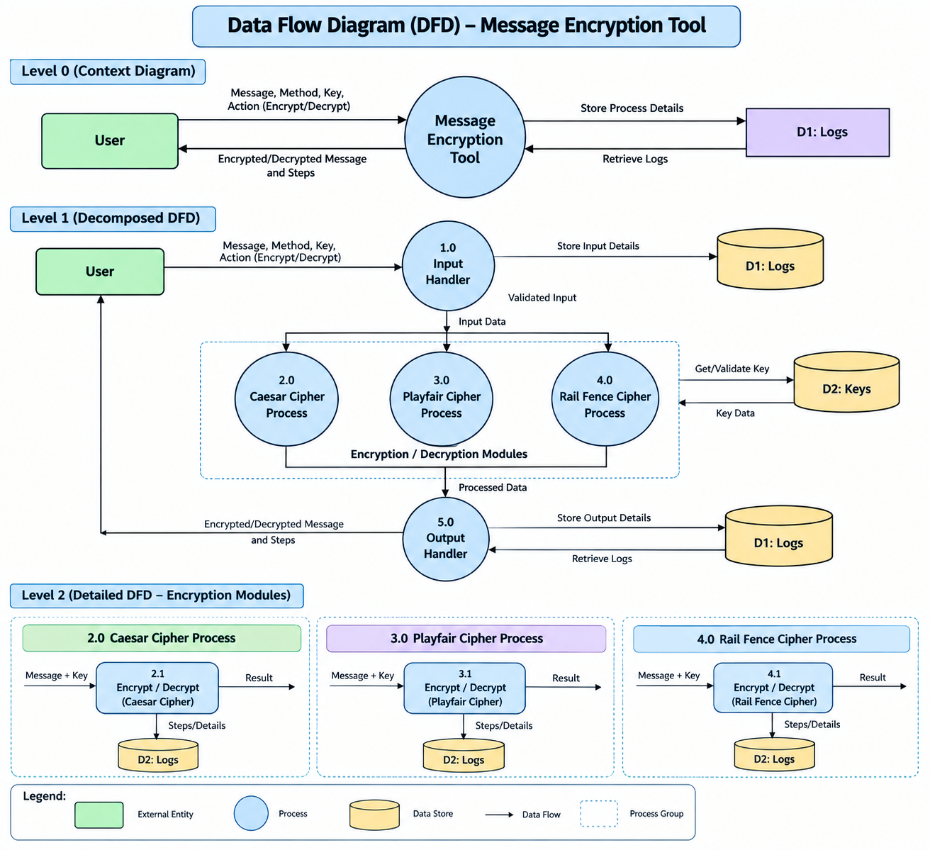

5.4 Class Diagram:-

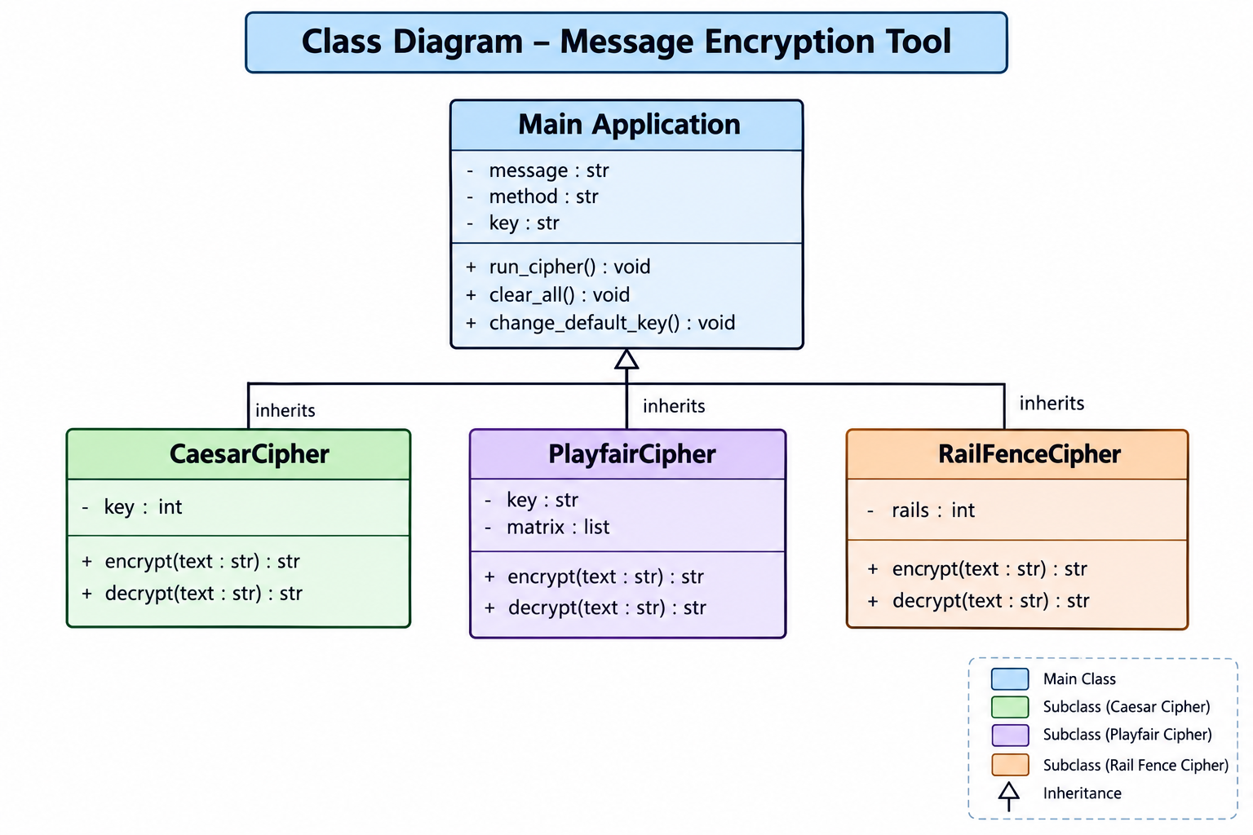

5.5 Use Case Diagram:-
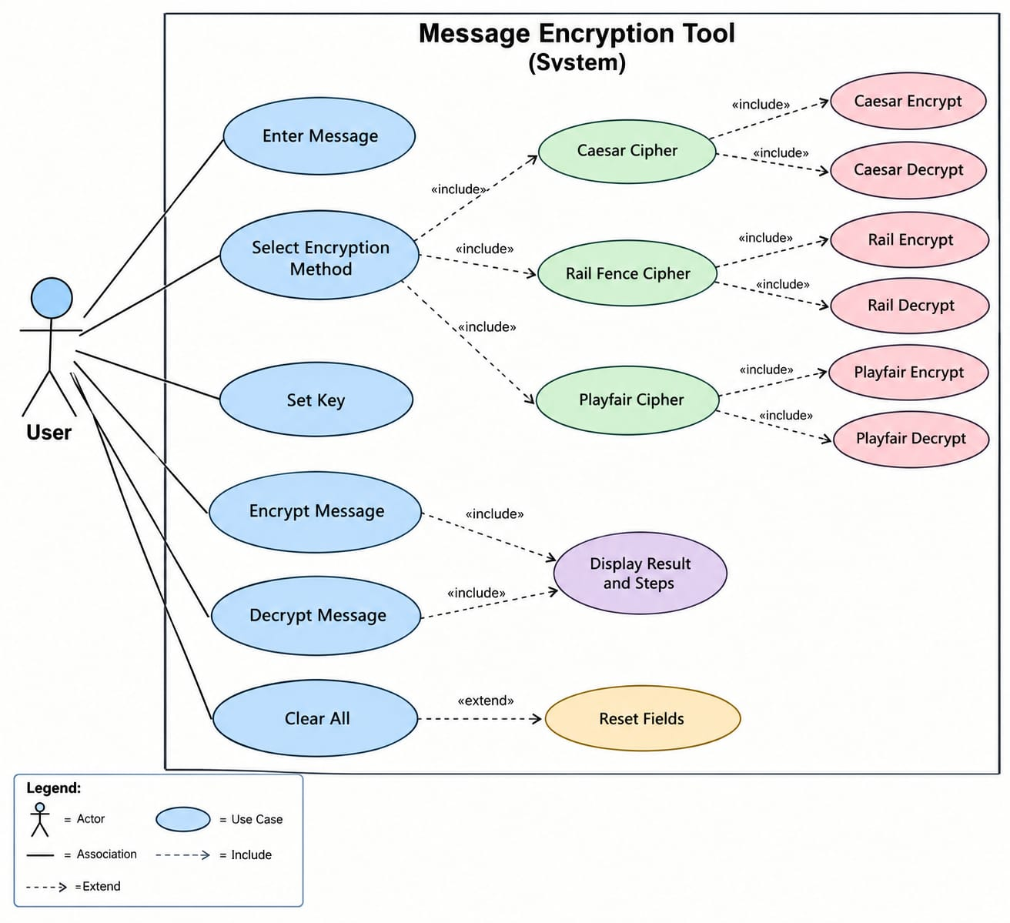

5.6 Sequential Diagram:-

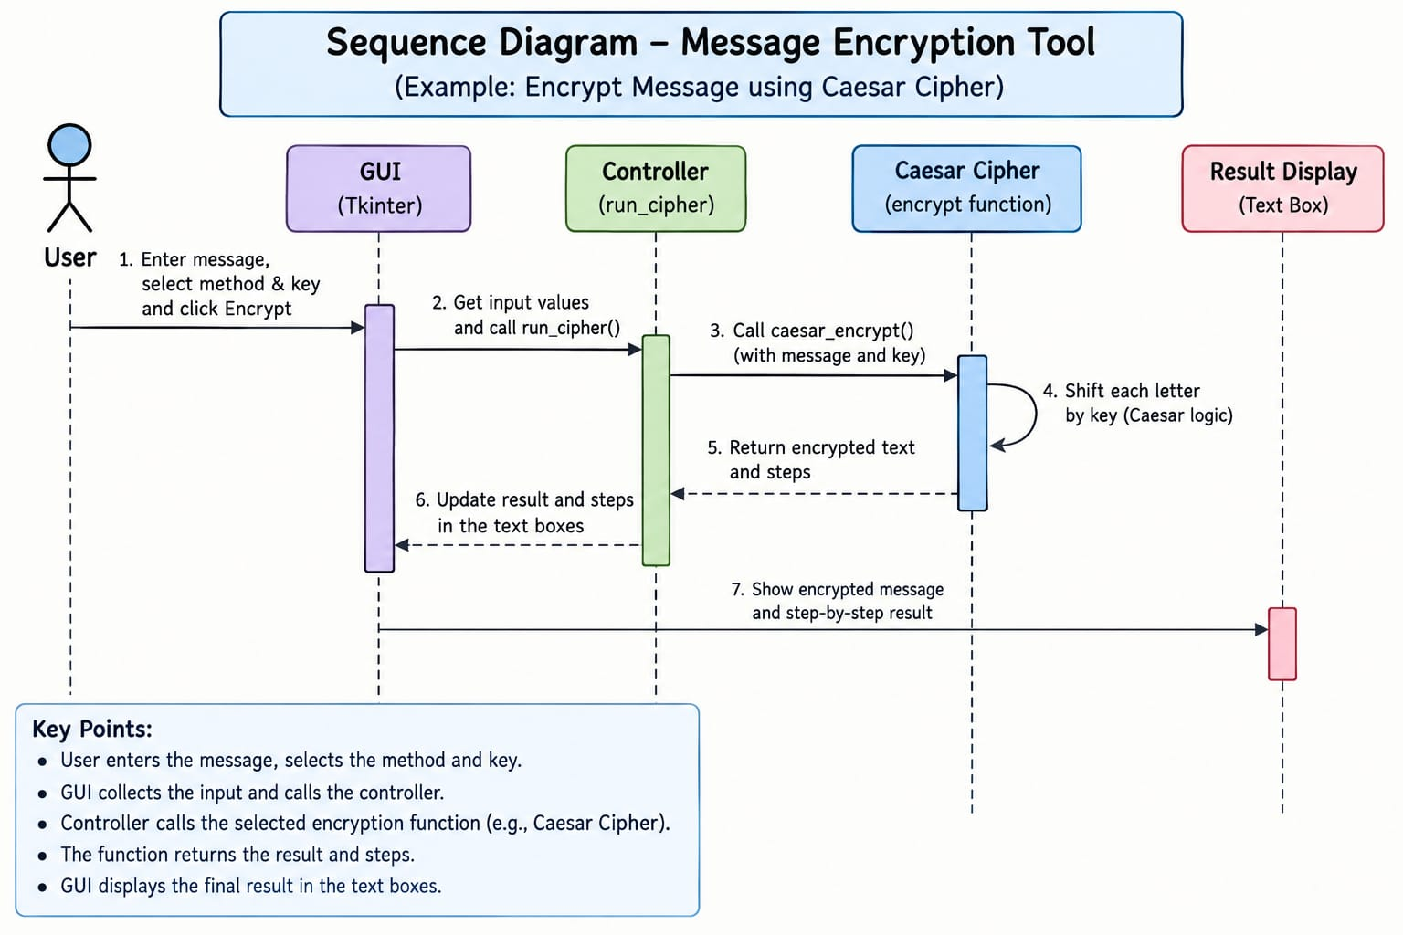

5.7 Activity Diagram :-

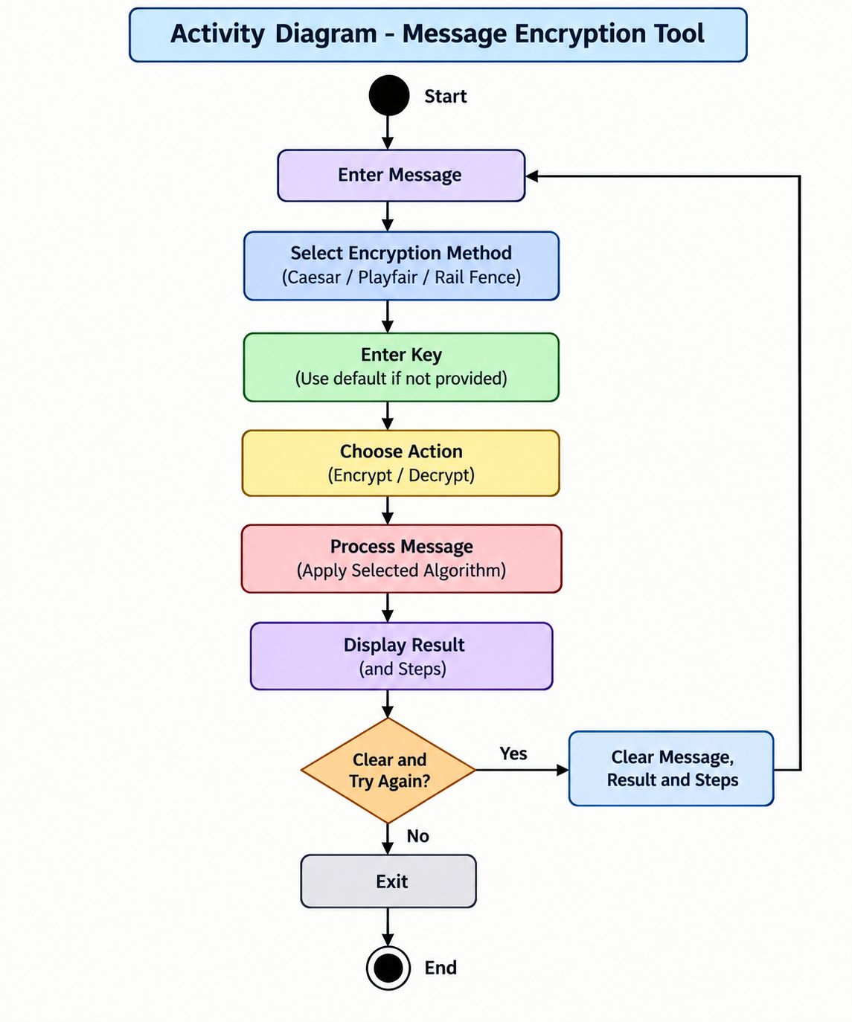

5.8 Menu Design:-

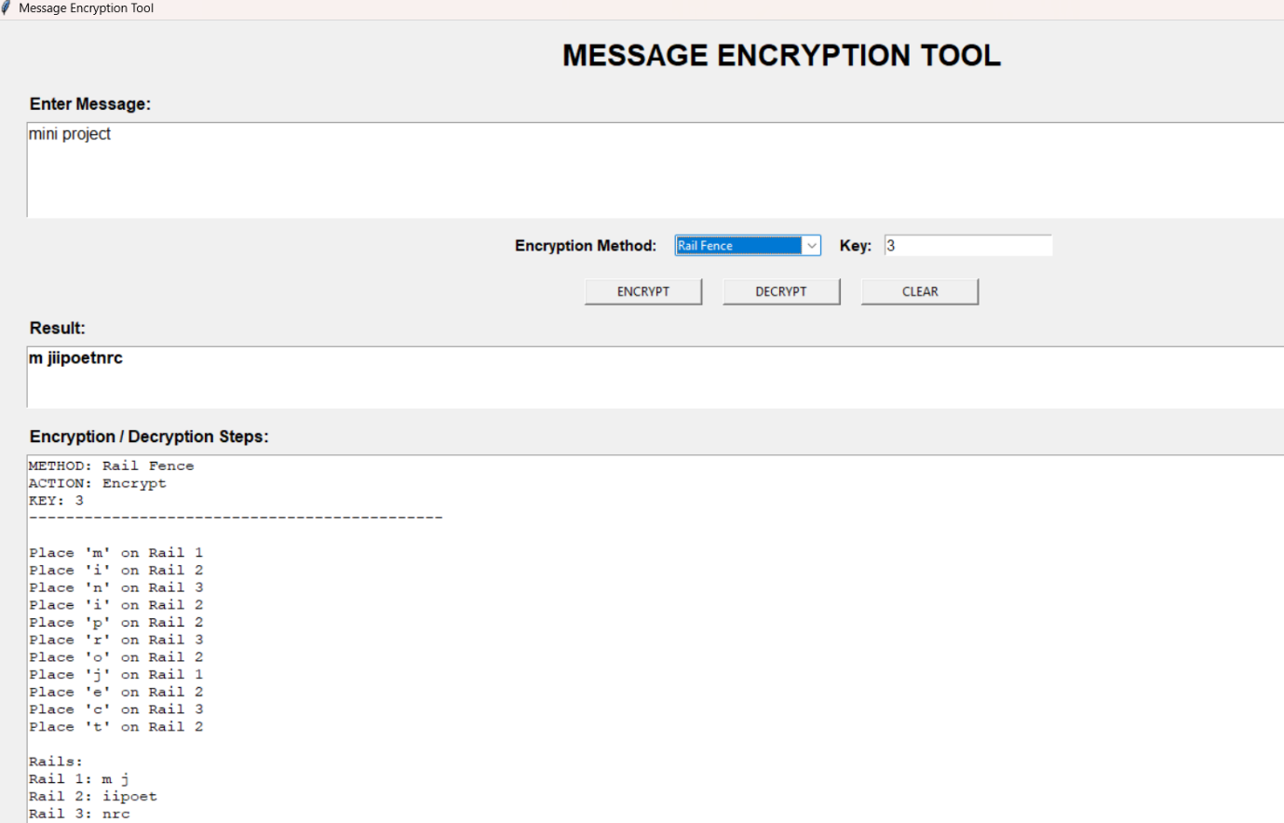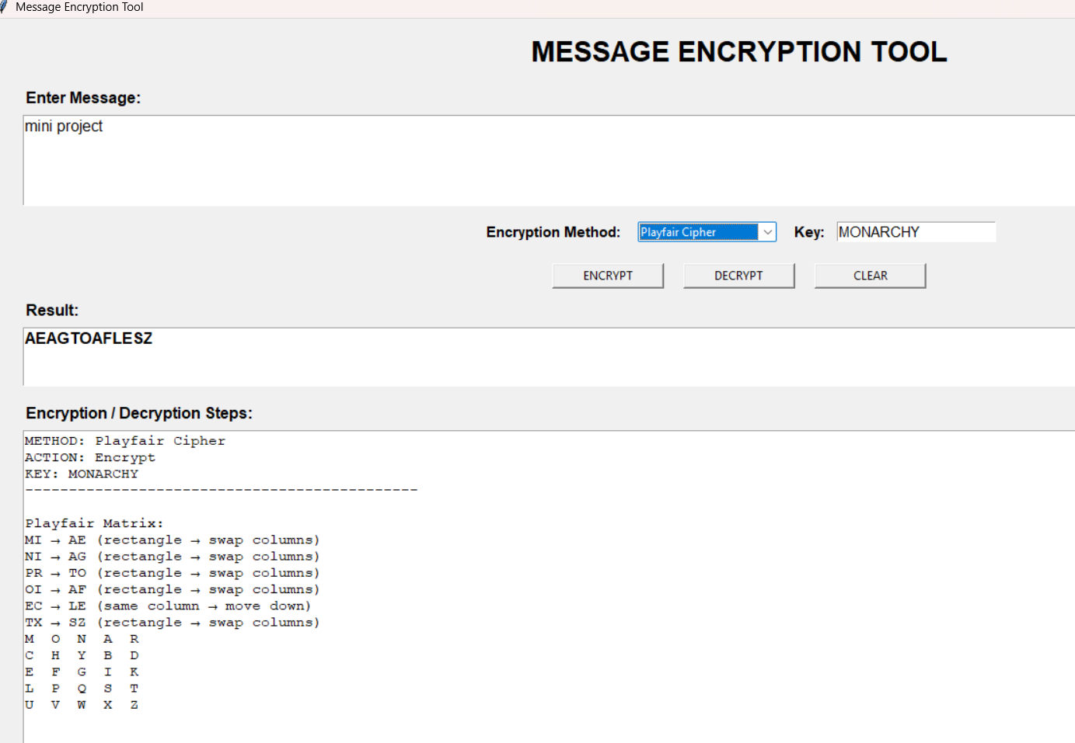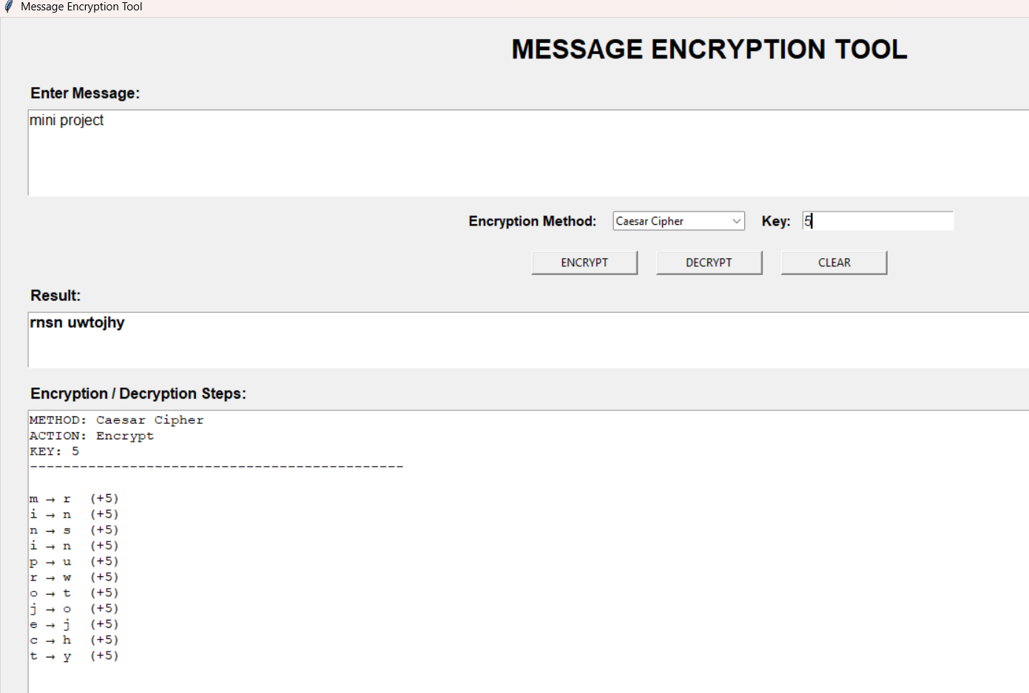

5.9 Code Of The Module:-

import tkinter as tk
from tkinter import ttk, messagebox

# ---------------- CAESAR CIPHER ----------------

def caesar_encrypt(text, key):
result = ""
steps = []

for ch in text:
if ch.isalpha():
base = ord('A') if ch.isupper() else ord('a')
new_ch = chr((ord(ch) - base + key) % 26 + base)
result += new_ch
steps.append(f"{ch} → {new_ch} (+{key})")
else:
result += ch

return result, steps

def caesar_decrypt(text, key):
result = ""
steps = []

for ch in text:
if ch.isalpha():
base = ord('A') if ch.isupper() else ord('a')
new_ch = chr((ord(ch) - base - key) % 26 + base)
result += new_ch
steps.append(f"{ch} → {new_ch} (-{key})")
else:
result += ch

return result, steps

# ---------------- RAIL FENCE CIPHER ----------------

def rail_encrypt(text, rails):
if rails <= 1:
return text, ["Only one rail: message remains unchanged."]

fence = [''] * rails
rail = 0
direction = 1
steps = []

for ch in text:
fence[rail] += ch

if ch != ' ':
steps.append(f"Place '{ch}' on Rail {rail + 1}")

if rail == 0:
direction = 1
elif rail == rails - 1:
direction = -1

rail += direction

result = ''.join(fence)

steps.append("")
steps.append("Rails:")
for i in range(rails):
steps.append(f"Rail {i + 1}: {fence[i]}")

return result, steps

def rail_decrypt(cipher, rails):
if rails <= 1:
return cipher, ["Only one rail: message remains unchanged."]

length = len(cipher)
pattern = []
rail = 0
direction = 1

for i in range(length):
pattern.append(rail)

if rail == 0:
direction = 1
elif rail == rails - 1:
direction = -1

rail += direction

counts = [pattern.count(i) for i in range(rails)]

fence = []
index = 0

for count in counts:
fence.append(list(cipher[index:index + count]))
index += count

positions = [0] * rails
result = ""
steps = []

for r in pattern:
result += fence[r][positions[r]]
steps.append(
f"Take '{fence[r][positions[r]]}' from Rail {r + 1}"
)
positions[r] += 1

return result, steps

# ---------------- PLAYFAIR CIPHER ----------------

def create_matrix(key):
key = ''.join(ch for ch in key.upper() if ch.isalpha())
key = key.replace('J', 'I')

alphabet = "ABCDEFGHIKLMNOPQRSTUVWXYZ"
letters = ""

for ch in key + alphabet:
if ch not in letters:
letters += ch

matrix = [letters[i:i + 5] for i in range(0, 25, 5)]
return matrix

def playfair_positions(matrix):
positions = {}

for r in range(5):
for c in range(5):
positions[matrix[r][c]] = (r, c)

return positions

def prepare_playfair(text):
text = ''.join(ch for ch in text.upper() if ch.isalpha())
text = text.replace('J', 'I')

pairs = []
i = 0

while i < len(text):
a = text[i]

if i + 1 >= len(text):
pairs.append(a + 'X')
i += 1
elif text[i] == text[i + 1]:
pairs.append(a + 'X')
i += 1
else:
pairs.append(a + text[i + 1])
i += 2

return pairs

def playfair_encrypt(text, key):
matrix = create_matrix(key)
pos = playfair_positions(matrix)
pairs = prepare_playfair(text)

result = ""
steps = []

for pair in pairs:
a, b = pair
r1, c1 = pos[a]
r2, c2 = pos[b]

if r1 == r2:
x = matrix[r1][(c1 + 1) % 5]
y = matrix[r2][(c2 + 1) % 5]
rule = "same row → move right"
elif c1 == c2:
x = matrix[(r1 + 1) % 5][c1]
y = matrix[(r2 + 1) % 5][c2]
rule = "same column → move down"
else:
x = matrix[r1][c2]
y = matrix[r2][c1]
rule = "rectangle → swap columns"

result += x + y
steps.append(f"{pair} → {x}{y} ({rule})")

return result, matrix, steps

def playfair_decrypt(text, key):
matrix = create_matrix(key)
pos = playfair_positions(matrix)

text = ''.join(ch for ch in text.upper() if ch.isalpha())
text = text.replace('J', 'I')

if len(text) % 2 != 0:
text += 'X'

result = ""
steps = []

for i in range(0, len(text), 2):
a = text[i]
b = text[i + 1]

r1, c1 = pos[a]
r2, c2 = pos[b]

if r1 == r2:
x = matrix[r1][(c1 - 1) % 5]
y = matrix[r2][(c2 - 1) % 5]
rule = "same row → move left"
elif c1 == c2:
x = matrix[(r1 - 1) % 5][c1]
y = matrix[(r2 - 1) % 5][c2]
rule = "same column → move up"
else:
x = matrix[r1][c2]
y = matrix[r2][c1]
rule = "rectangle → swap columns"

result += x + y
steps.append(f"{a}{b} → {x}{y} ({rule})")

return result, matrix, steps

# ---------------- GUI ----------------

def run_cipher(action):
message = message_box.get("1.0", tk.END).strip()
method = method_var.get()
key = key_entry.get().strip()

if not message:
messagebox.showwarning("Warning", "Please enter a message.")
return

try:
if method == "Caesar Cipher":

if not key:
key = "3"

key = int(key)

if action == "Encrypt":
result, steps = caesar_encrypt(message, key)
else:
result, steps = caesar_decrypt(message, key)

elif method == "Rail Fence":

if not key:
key = "3"

rails = int(key)

if rails < 2:
raise ValueError

if action == "Encrypt":
result, steps = rail_encrypt(message, rails)
else:
result, steps = rail_decrypt(message, rails)

elif method == "Playfair Cipher":

if not key:
key = "MONARCHY"

if action == "Encrypt":
result, matrix, steps = playfair_encrypt(message, key)
else:
result, matrix, steps = playfair_decrypt(message, key)

steps.insert(0, "Playfair Matrix:")

for row in matrix:
steps.append(" ".join(row))

steps.append("")

result_box.config(state="normal")
result_box.delete("1.0", tk.END)
result_box.insert(tk.END, result)
result_box.config(state="disabled")

steps_box.config(state="normal")
steps_box.delete("1.0", tk.END)

steps_box.insert(
tk.END,
f"METHOD: {method}\n"
f"ACTION: {action}\n"
f"KEY: {key}\n"
f"{'-' * 45}\n\n"
)

for step in steps:
steps_box.insert(tk.END, step + "\n")

steps_box.config(state="disabled")

except ValueError:
messagebox.showerror(
"Invalid Key",
"Please enter a valid numeric key."
)

def clear_all():
message_box.delete("1.0", tk.END)

result_box.config(state="normal")
result_box.delete("1.0", tk.END)
result_box.config(state="disabled")

steps_box.config(state="normal")
steps_box.delete("1.0", tk.END)
steps_box.config(state="disabled")

def change_default_key(event=None):
method = method_var.get()

if method == "Caesar Cipher":
key_entry.delete(0, tk.END)
key_entry.insert(0, "3")

elif method == "Playfair Cipher":
key_entry.delete(0, tk.END)
key_entry.insert(0, "MONARCHY")

elif method == "Rail Fence":
key_entry.delete(0, tk.END)
key_entry.insert(0, "3")

# ---------------- WINDOW ----------------

root = tk.Tk()
root.title("Cipher Guard")
root.geometry("900x700")
root.minsize(800, 600)

title = tk.Label(
root,
text="CIPHER GUARD",
font=("Arial", 22, "bold")
)
title.pack(pady=15)

# Message

tk.Label(
root,
text="Enter Message:",
font=("Arial", 12, "bold")
).pack(anchor="w", padx=30)

message_box = tk.Text(
root,
height=5,
font=("Arial", 12)
)
message_box.pack(fill="x", padx=30, pady=5)

# Method

frame = tk.Frame(root)
frame.pack(pady=10)

tk.Label(
frame,
text="Encryption Method:",
font=("Arial", 11, "bold")
).grid(row=0, column=0, padx=5)

method_var = tk.StringVar(value="Caesar Cipher")

method_menu = ttk.Combobox(
frame,
textvariable=method_var,
values=[
"Caesar Cipher",
"Playfair Cipher",
"Rail Fence"
],
state="readonly",
width=20
)
method_menu.grid(row=0, column=1, padx=10)
method_menu.bind("<<ComboboxSelected>>", change_default_key)

tk.Label(
frame,
text="Key:",
font=("Arial", 11, "bold")
).grid(row=0, column=2, padx=5)

key_entry = tk.Entry(
frame,
width=20,
font=("Arial", 11)
)
key_entry.insert(0, "3")
key_entry.grid(row=0, column=3, padx=5)

# Buttons

button_frame = tk.Frame(root)
button_frame.pack(pady=10)

tk.Button(
button_frame,
text="ENCRYPT",
width=15,
command=lambda: run_cipher("Encrypt")
).grid(row=0, column=0, padx=10)

tk.Button(
button_frame,
text="DECRYPT",
width=15,
command=lambda: run_cipher("Decrypt")
).grid(row=0, column=1, padx=10)

tk.Button(
button_frame,
text="CLEAR",
width=15,
command=clear_all
).grid(row=0, column=2, padx=10)

# Result

tk.Label(
root,
text="Result:",
font=("Arial", 12, "bold")
).pack(anchor="w", padx=30)

result_box = tk.Text(
root,
height=3,
font=("Arial", 13, "bold")
)
result_box.pack(fill="x", padx=30, pady=5)
result_box.config(state="disabled")

# Steps

tk.Label(
root,
text="Encryption / Decryption Steps:",
font=("Arial", 12, "bold")
).pack(anchor="w", padx=30, pady=(10, 0))

steps_box = tk.Text(
root,
height=15,
font=("Courier New", 11)
)
steps_box.pack(fill="both", expand=True, padx=30, pady=5)
steps_box.config(state="disabled")

root.mainloop()

6. System Testing :-

- Test valid and empty message inputs.
- Test Caesar, Playfair, and Rail Fence encryption/decryption.
- Test valid and invalid keys.
- Check default keys when no key is entered.
- Test the Clear button.
- Verify that encrypted/decrypted results are displayed correctly.
- Check all GUI buttons, fields, and menus.

7. Coclusion :-

The Cipher Guard successfully demonstrates the basic concepts of cryptography using Caesar Cipher, Playfair Cipher, and Rail Fence Cipher. The tool provides a simple and user-friendly interface for encrypting and decrypting messages. This project helped in understanding different encryption techniques and their practical implementation using Python.

8. Learning During Project Work :-

LEARNING DURING PROJECT WORK
During this project, we learned:

- Basic concepts of cryptography and message encryption.

- Working of Caesar, Playfair, and Rail Fence ciphers.

- Implementation of encryption and decryption using Python.

- Creating a simple GUI using Tkinter.

- Handling user input, keys, errors, and displaying results.

- Understanding the importance of data security and information protection.

8.1 Future Enhancement:-

- Add advanced encryption methods like AES and RSA.
- Add password-based security.
- Add file encryption.
- Improve the GUI design.
- Develop a web or mobile version.

9. Reference :-

Chatgpt , geeksforgeeks , Tkinter Documentation – Python GUI

